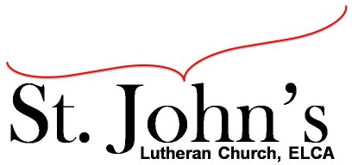A Christ-centered community
welcoming all people and serving God through the Holy Spirit.

As our congregation's leaders, we hear the call to be authentic, affirming, and available.

Council Meeting Agenda for January 18, 2022, at 7:00PM

Council members present: Pastor Gary Kinkel, Jesse Rients, Erik Vangsness, Kirsti Youngs, Aimee Johnson, Mike Laurel, Paula Brennan. Guest: Angel Zollner

I. Gathering
- Call to order 7:04pm
- Motion to approve agenda – Pastor Gary Kinkel / Paula Brennan; carried.
- Scripture and prayer: Pastor Gary Kinkel – The Council in the Word: Acts 18:1-
- Old business – St. John’s will be included in the “Welcome to the Neighborhood” brochure that is given out to people who move into Shakopee / Scott County. The brochure is printed once per year in September ($195), and although we have missed the cut-off, St. John’s will be included as a separate insert inside the brochure for half the price.
- Mike Laurel – Snow removal company will provide salt for $60 per incident. We will route a sign-up sheet this Sunday (1/23) during worship for volunteers to check sidewalks and shovel and/or salt when needed.
- Check with insurance company to see if there is savings / credit reflected as a result of safety / energy / equipment improvements have been made. Also, after Sean completes boiler certification.

II. Discerning Our Mission
- Talking points from the Youth meeting
– Survey the congregation
– Possibly moving Sunday School education to Wednesday evenings, at the same time as confirmation.
– Further discussion next council meeting regarding “The Word on Wednesday”.
– Bring back Children’s service during regular worship until “Word on Wednesday” is up and running.

III. Giving Thanks
- Treasurer’s Report – Erik Vangsness. Council will vote to approve final treasurer’s report via email.
Motion to approve draft 2022 budget: Pastor Gary Kinkel / Kirsti Youngs; carried.
- Motion to approve December council minutes: Pastor Gary Kinkel / Kirsti Youngs; carried.

IV. Sending
- Review action items established—next council meeting date February 15, 2022
- Closing Prayer – Pastor Gary Kinkel
- Adjournment – 8:36pm

Respectfully submitted,
Paula Brennan, Council Vice President

Meeting Ground Rules: *Keep it real,* Everyone participates, *Different opinions encouraged,
*Disagree in private, *Unite in public, * Silence is agreement, * Limit side conversations, * Start on time, *Follow through on action plans.

