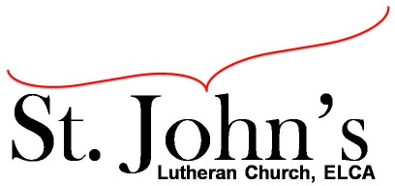A Christ-centered community
welcoming all people and serving God through the Holy Spirit.

As our congregation's leaders, we hear the call to be authentic, affirming, and available.

Council Meeting Agenda for February 15, 2022, at 7:00PM

Council members present: Pastor Gary Kinkel, Chris Taylor, Erik Vangsness, Kirsti Youngs, Annie Rients, Angel Zollner
Guests: Scott Myland, Corporate Technologies; Justin Lewandowski, Beacon

I. Gathering
- Call to order 7:04pm, Chris Taylor
- Council Introductions
- Scripture and prayer: Pastor Gary Kinkel – The Council in the Word: Acts 18:12-17

II. Discerning Our Mission
- Presentation by Scott Myland, Corporate Technologies – Scott provided information on how his company may be able to provide IT support services to St. John’s. Scott will supply his detailed slide presentation to Pastor Gary for council distribution. Erik Vangsness requested that Scott provide a proposal for the services mentioned in his presentation.
- Justin Lewandowski from Beacon provided the council with information about Beacon’s mission and updates on their projects, including Prairie Point supportive housing in Shakopee. Justin is interested in continuing Beacon’s relationship with St. John’s.
- Council Retreat and Council Member Installation – dates for both to be determined
- Council Recruitment – Two to three more council positions to be filled, including Vice President, Management and Properties Team Lead and Finance Chair
- 2022 Council Goals – to be determined

III. Giving Thanks
- Treasurer’s Report – Erik Vangsness – Council will approve via email when all information is available.
- Motion to approve January council minutes: Annie Rients /Pastor Gary; carried.

IV. Sending
- Review action items established—next council meeting date March 15, 2022
- Closing Prayer – Pastor Gary Kinkel
- Adjournment – Motion to adjourn; Annie Rients / Pastor Gary Kinkel; carried 8:32pm.

Respectfully submitted,
Angel Zollner, Council Secretary

Meeting Ground Rules: *Keep it real,* Everyone participates, *Different opinions encouraged,
*Disagree in private, *Unite in public, * Silence is agreement, * Limit side conversations, * Start on time, *Follow through on action plans.

