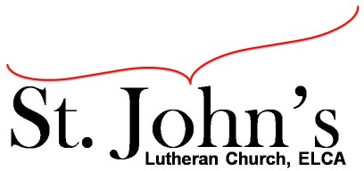A Christ-centered community
welcoming all people and serving God through the Holy Spirit.

As our congregation's leaders, we hear the call to be authentic, affirming, and available.

Council Meeting Agenda for Apr. 20, 2021, at 7:00PM

Council members present: Pastor Gary Kinkel, Pastor Jerod Freeberg, Jesse Rients,
Kirsti Youngs, Erik Vangsness, Mike Laurel, Paula Brennan

Council members absent: Aimee Johnson

I. Gathering
- Call to order – Jesse Rients, 7:04pm
- Motion to approve agenda – Pastor Gary Kinkel / Kirsti Youngs, carried.
- Scripture and prayer – Pastor Gary Kinkel – The Council in the Word: Acts 16:1-10

II. Discerning Our Mission
- In-person / outdoor services – Weather permitting, we will begin worship outdoors on May 2. In the event of inclement weather, we will worship in our vehicles via the transmitter.
- Stewardship – The Stewardship team will have their first session meeting via Zoom early in May.

III. Giving Thanks
- Treasurer’s Report – Erik Vangsness – Council will approve treasurer’s report when complete via email.
- Motion to approve council minutes – Pastor Gary Kinkel / Erik Vangsness; carried.

IV. Sending
- Review action items established—next council meeting date May 18, 2021.
- Closing Prayer – Pastor Jerod Freeberg
- Adjournment – Motion to adjourn; Kirsti Youngs / Mike Laurel; carried 8:15pm.

Respectfully Submitted,
Paula Brennan, Council Vice President

Meeting Ground Rules: *Keep it real,* Everyone participates, *Different opinions encouraged,
*Disagree in private, *Unite in public, * Silence is agreement, * Limit side conversations, * Start on time, *Follow through on action plans.

