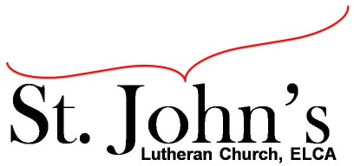A Christ-centered community
welcoming all people and serving God through the Holy Spirit.

As our congregation's leaders, we hear the call to be authentic, affirming, and available.

Council Meeting Agenda for May 18, 2021, at 7:00pm

Council Members present: Pastor Gary Kinkel, Pastor Jerod Freeberg, Jesse Rients,
Mike Laurel, Erik Vangsness, Aimee Johnson, Paula Brennan

Council Members absent: Kirsti Youngs

I. Gathering
Call to order – Jess Rients, 7:08pm
- Motion to approve agenda: Pastor Gary Kinkel / Aimee Johnson; carried.
- Scripture and prayer: Pastor Gary Kinkel – The Council in the Word: Acts 16:11-15

II. Discerning Our Mission
- In-person / outdoor services –
Motion to have in-person worship resume June 13 with appropriate social distancing and masks worn; Aimee Johnson / Pastor Gary Kinkel; carried.
- Building update – Mike Laurel – rooftop unit was replaced 3 weeks ago.

III. Giving Thanks
- Treasurer’s Report – Erik Vangsness
Motion to accept March financial reports; Pastor Gary Kinkel / Mike Laurel; carried. Motion to accept April financial reports; Pastor Gary Kinkel / Aimee Johnson; carried.
- Motion to approve April council minutes; Pastor Gary Kinkel / Mike Laurel; carried.

IV. Sending
- Review action items established—next council meeting date June 15, 2021
- Closing Prayer – Pastor Jerod Freeberg
- Adjournment – Motion to adjourn; Pastor Gary Kinkel / Paula Brennan; carried 8:25pm.

Respectfully submitted,
Paula Brennan, Council Vice President

Meeting Ground Rules: *Keep it real, * Everyone participates, *Different opinions encouraged,
*Disagree in private, *Unite in public, * Silence is agreement, * Limit side conversations, * Start on time, *Follow through on action plans.

