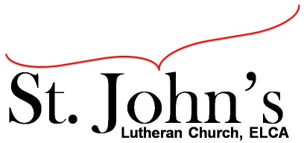A Christ-centered community
welcoming all people and serving God through the Holy Spirit.

As our congregation's leaders, we hear the call to be authentic, affirming, and available.

Council Members present: Pastor Gary Kinkel, Pastor Jerod Freeberg, Jesse Rients,
Erik Vangsness, Kirsti Youngs, Aimee Johnson, Mike Laurel, Paula Brennan

Council Meeting Agenda for June 15, 2021, at 7:00PM

I. Gathering
- Call to order: Jesse Rients, 7:03pm
- Motion to approve agenda: Pastor Gary Kinkel / Mike Laurel; carried.
- Scripture and prayer: Pastor Gary Kinkel - The Council in the Word: Acts 16:16-24

II. Discerning Our Mission
- Stewardship – Stewardship committee proposal
- Building issues – Mike Laurel shared the water heater needs to be replaced, possibly $6000. Mike is collecting bids. Immediate need is for Loaves & Fishes.

III. Giving Thanks
- Treasurer’s Report – Erik Vangsness
Motion to apply for an EnerChange efficiency loan for building / infrastructure repairs: Pastor Gary Kinkel / Kirsti Youngs; carried.
Motion to empower Erik to speak with Mike Sexton requesting a loan from the Endowment Committee to cover shortage of salaries: Pastor Gary / Erik Vangsness; carried.
- Motion to approve May council meeting minutes: Erik Vangsness / Pastor Gary Kinkel; carried.

IV. Sending
- Review action items established—next council meeting date July 20, 2021.
- Closing Prayer – Mike Laurel
- Adjournment – Motion to adjourn: Kirsti Youngs / Erik Vangsness, carried 8:40pm.

Respectfully Submitted,
Paula Brennan, Council Vice President

Meeting Ground Rules: *Keep it real,* Everyone participates, *Different opinions encouraged,
*Disagree in private, *Unite in public, * Silence is agreement, * Limit side conversations, * Start on time, *Follow through on action plans.

