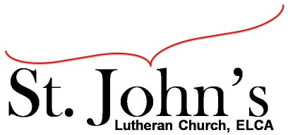A Christ-centered community
welcoming all people and serving God through the Holy Spirit.

As our congregation's leaders, we hear the call to be authentic, affirming, and available.

Council Members present: Pastor Gary Kinkel, Pastor Jerod Freeberg, Jesse Rients,
Erik Vangsness, Mike Laurel, Kirsti Youngs, Paula Brennan

Council Meeting Agenda for July 20, 2021, at 7:00PM

I. Gathering
- Call to order – Jesse Reints, 7:11pm
- Motion to approve agenda: Pastor Gary Kinkel / Paula Brennan; carried.
- Scripture and prayer – Pastor Gary Kinkel, The Council in the Word, Acts 16:25-34

II. Discerning Our Mission
- Line of credit – Erik Vangsness – ELCA Credit Union – Congregational vote is required and will be scheduled for August 8 at the beginning of worship.
- Building infrastructure – Erik Vangsness & Mike Laurel – a loan is necessary for appropriate repairs, plumbing / demo, etc. This will also be voted on August 8, permission from the congregation to borrow funds.
- Stewardship/giving – $20,000 Fundraising campaign is going well – letters have been sent to the congregation.

III. Giving Thanks
- Treasurer’s Report – Erik Vangsness – Treasurer’s Report will be approved via email.
- Motion to approve June Treasurer’s Report; Kirsti Youngs / Mike Laurel; carried.
- Motion to approve June council minutes – Mike Laurel / Pastor Gary Kinkel; carried.

IV. Sending
- Review action items established—next council meeting date August 17, 2021
- Closing Prayer – Pastor Jerod Freeberg
- Adjournment – Motion to Adjourn: Pastor Gary Kinkel / Mike Laurel; carried 8:11pm.

Meeting Ground Rules: *Keep it real,* Everyone participates, *Different opinions encouraged,
*Disagree in private, *Unite in public, * Silence is agreement, * Limit side conversations, * Start on time, *Follow through on action plans.

