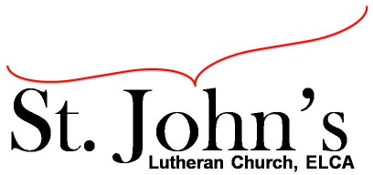A Christ-centered community
welcoming all people and serving God through the Holy Spirit.

As our congregation's leaders, we hear the call to be authentic, affirming, and available.

Council Meeting Agenda for October 19, 2021, at 7:00PM

Council Members present: Pastor Jerod Freeberg, Jesse Rients, Mike Laurel, Aimee Johnson, Kirsti Youngs, Erik Vangsness, Paula Brennan

Council Members absent: Pastor Gary Kinkel

I. Gathering
- Call to order 7:34pm
- Motion to approve agenda: Paula Brennan / Kirsti Youngs; carried.
- Scripture and prayer: Pastor Jerod Freeberg; Mark 10:46-52

II. Discerning Our Mission
- Service sign up: Pastor Gary and Lisa will create a sign-up sheet to pass during worship.
- Stewardship – Thank you to all the people on the Stewardship Committee for all your efforts. This is a lot of work and does not go unnoticed!
- There is no children’s service this week due to MEA.
- Building Update: Mike Laurel – asbestos was removed this week. Hoping to meet deadline for the loan, approaching 90 day mark.

III. Giving Thanks
- Treasurer’s Report: Erik Vangsness provided preliminary Treasurer’s Report.
- Motion to approve council minutes: Aimee Johnson / Mike Laurel; carried.

IV. Sending
- Review action items established – next council meeting date November 16, 2021
- Closing Prayer: Pastor Jerod Freeberg
- Adjournment – Motion to adjourn: Erik Vangsness / Kirsti Youngs; carried 8:12pm.

Respectfully submitted,
Paula Brennan, Council Vice President

Meeting Ground Rules: *Keep it real,* Everyone participates, *Different opinions encouraged,
*Disagree in private, *Unite in public,* Silence is agreement, * Limit side conversations, * Start on time, *Follow through on action plans.

