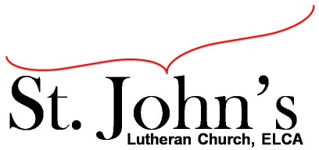A Christ-centered community
welcoming all people and serving God through the Holy Spirit.

As our congregation's leaders, we hear the call to be authentic, affirming, and available.

Council Meeting Agenda for November 16, 2021, at 7:00pm

Council Members present: Pastor Gary Kinkel, Pastor Jerod Freeberg, Jesse Rients,
Erik Vangsness, Mike Laurel, Aimee Johnson, Kirsti Youngs, Paula Brennan

I. Gathering
- Call to order: Jesse Rients, 7:05pm
- Motion to approve agenda – Pastor Gary Kinkel / Paula Brennan; carried.
- Scripture and prayer: Pastor Gary Kinkel – The Council in the Word: Acts 17:10-15

II. Discerning Our Mission
- Building update: Mike Laurel – Rooftop unit had part replaced (under warranty), removed chimney, boiler switch, licensing for boiler maintenance. Approximately $1000 in boiler updates to meet insurance requirements. Fire Marshall requires inspection, testing, and documentation.
- Stewardship update: 30 Commitment cards received on Sunday total $20,000 more than 2020 offerings received.

III. Giving Thanks
- Treasurer’s Report: Erik Vangsness – October draft report, council will approve final report via email. Vote to approve contract for loan from Endowment Committee.
Motion to approve contract for loan from Endowment Committee – Erik Vangsness / Pastor Gary Kinkel; carried.
- Motion to approve council minutes – Kirsti Youngs / Erik Vangsness; carried.

IV. Sending
- Review action items established—next council meeting date December 21, 2021
- Closing Prayer: Pastor Jerod Freeberg.
- Adjournment: Motion to adjourn – Pastor Gary Kinkel / Pastor Jerod Freeberg; carried 8:21pm.

Respectfully submitted,
Paula Brennan, Council Vice President

Meeting Ground Rules: *Keep it real,* Everyone participates, *Different opinions encouraged,
*Disagree in private, *Unite in public, * Silence is agreement, * Limit side conversations, * Start on time, *Follow through on action plans.

